Soup & Study
for ADVENT
led by Rev. Angela Madden Scott

Mondays on December 2, 9, 16, and 23 @ 5:15-6:15 pm
First Presbyterian Church Granbury
Fellowship Hall, 300 West Bridge Street
Childcare provided inside Fellowship Hall
Staffed by Jessica Roberson

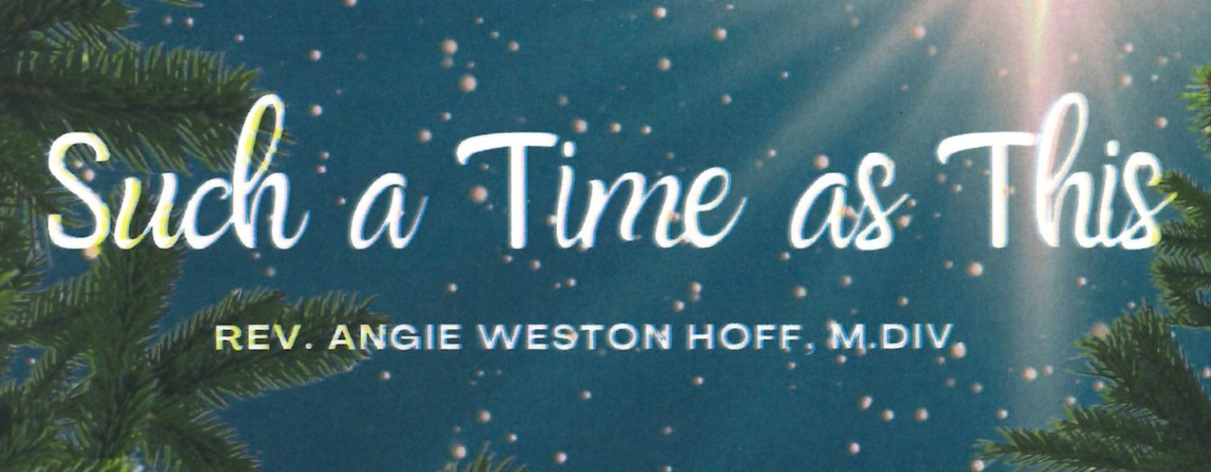
Based on the book by Rev. Angie Weston Hoff M.Div.
Dec. 2 Part 1: You have found favor
Dec. 9 Part 2: Pain, Pressure, PEACE
Dec. 16 Part 3: Why do we give gifts on someone else’s
birthday?
Dec. 23 Part 4: When light breaks the night

